# CENTRE FOR DEVELOPMENT OF ADVANCED COMPUTING

A Project Report On

**Car Showroom Management System**

### SUBMITTED IN PARTIAL FULFILLMENT FOR THE AWARD OF

PG DIPLOMA IN ADVANCED COMPUTING

FROM C-DAC Knowledge Park Bangalore

**Guided by- Submitted By-**

Vasu Sir Akshay Jain (DAC 09)

Ashutosh Kumar (DAC 22) Furkan(DAC 36)

Prakhar Upadhyay (DAC 76) Rishabh Singh(DAC 83)

# CENTRE FOR DEVELOPMENT OF ADVANCED COMPUTING

**Acknowledgement**

First and foremost, we offer our sincerest gratitude to our supervisor respected **Vasu sir** who has supported us in our project with his utmost patience and enlightened us with his vast pool of knowledge whilst allowing us the room to work in our way.

We would like to express our gratitude towards **Shamughanthan Sir** and **Binu Ma’am** for their valuable guidance and for completing this project. There useful suggestion for this whole work and co-operative behaviour are sincerely acknowledged.

# CENTRE FOR DEVELOPMENT OF ADVANCED COMPUTING

**CERTIFICATE OF APPROVAL OF PROJECT WORK**

This is to certify that the project titled “O2Commerce” submitted by Akshay Jain(09), Ashutosh Kumar(22),Furkan(36),Prakhar Upadhyay(76),Rishabh singh(83) in partial fulfillment of the

requirements for the award of PG Diploma in Advanced Computing from CDAC Knowledge Park

Bangalore.

|  |  |  |
| --- | --- | --- |
| **Signature** | **Signature** | **Signature** |
| **(Vasu Sir)** | **(Shamughanthan Sir)** | **(Binu Ma’am)** |
| **Project Guide** |  | **Course Coordinator** |

# CENTRE FOR DEVELOPMENT OF ADVANCED COMPUTING

**Abstract**

O2commerce is a concept which means online to offline service. User can order or book any services online and get the service offline. It is a REST API. We provide an interface for seller who provide the services and customer who can use those services. It has password-less login mechanism. We have used token for authentication and for session management.

# CENTRE FOR DEVELOPMENT OF ADVANCED COMPUTING

## Introduction

* 1. **Purpose:** O2commerce is a concept which means online to offline service. User can order or book any services online and get the service offline**.**

## System Design :

* 1. **Dataflow Diagram** -A Data Flow Diagram (DFD) is a graphical representation of the flow “O2Commerce”.DFD shows the interaction between the system and outside entities.

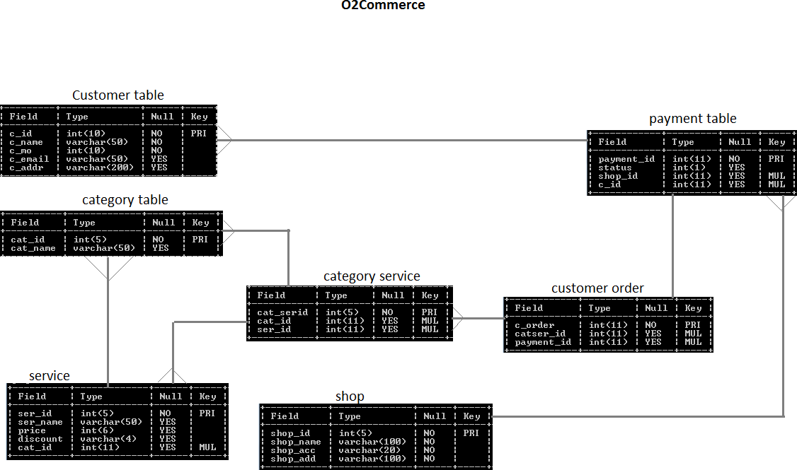

* 1. **Use Case Diagram-** The use case diagram depicts the essential functionality and actors of the application namely seller and user.

1. **Analysis**: The basic requirements for the design of the O2Commerce is every user should have their own identity.

# CENTRE FOR DEVELOPMENT OF ADVANCED COMPUTING

* 1. **Functional Requirements-**O2Commerce aims to provide online to offline service where service has to be booked online and the services will be given offline.

# Technology used-

* 1. **MySQL** - It is an open source relational database management system which contains the database.
  2. **SpringMVC** – It is a framework of spring which is used to develop web applications and we used to integrate hibernate in to this framework.
  3. **Hibernate** - It is an object relational mapping tool for java and it provides framework for mapping object oriented model to relational database.
  4. **Angular 6** – It is a JavaScript framework for building web applications and apps in JavaScript, html, and TypeScript, which is a superset of JavaScript.
  5. **Node js**. – It can generate dynamic page content and used in back-end run time environment which facilitates event driven, asynchronous programming that makes it fast.The authentication part is done in this.
  6. **Maven** – It addresses the aspects of building software that it describes its dependencies.
  7. **Redis** – It is used to save cookie and session in the cache memory and also helps in communication between two servers.
  8. **AccountKit** – It helps in password-less authentication for login and registeration by using phone number and e- mail.

# CENTRE FOR DEVELOPMENT OF ADVANCED COMPUTING

## Flow of Execution-

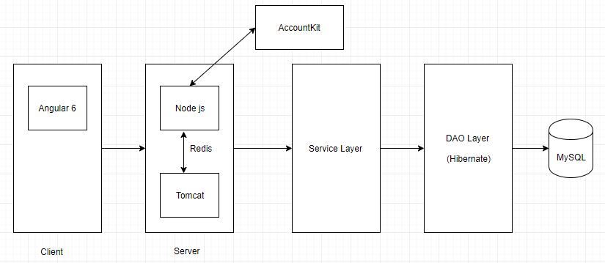

Client make request through Angular 6. Client may login through his mobile number or email id where he will receive respective OTP for authentication .

# CENTRE FOR DEVELOPMENT OF ADVANCED COMPUTING

## Conclusion:

* + We learned to connect two servers via redis.
  + Learned to consume another API.
  + How to implement password less mechanism using AccountKit.
  + Repeated restarts of node server following changes can be avoided by using nodemon.